**Install Guide**

**1. Run "Git-1.7.11-preview20120704.exe" to install msysgit**

**2. Run "KDiff3Setup_0.9.96.exe" to install tool for merging and comparing**

**3. Run "NGitDesktopSetup.msi" to install NGit**

**4. Open App’s Property window to configure the Ngit.**

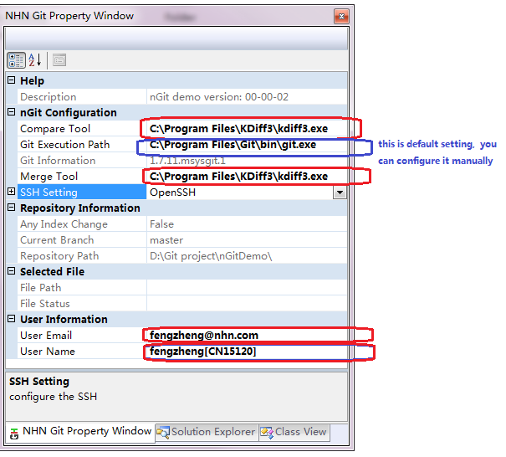

**5. All is ready, restart the explorer.**

**UI Help**

**The App includes two parts just as followed;**

1. **Shell Extensions**

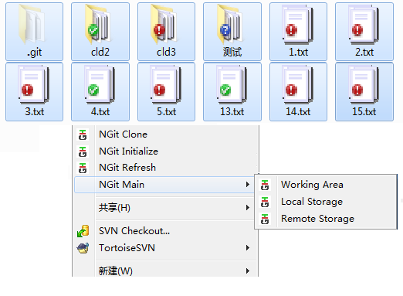

**1. File Status(New/Modified/Ignored/Commited/Conflicted)**

**2. Right-clicked Context Menu**

**1) NGit Clone:** Get local repository and working area from remote server

**2) NGit Initialize:** Create a repository in local machine

**3) NGit Refresh:** Update local repository and working area from remote server

**4) NGit Blame:** Review the history of the selected file.

**5) Working Area:** All operations about working area and index area

**6) Local Storage:** All operations in local repository

**7) Remote Storage:** All operations about remote server.

**2.Main App**

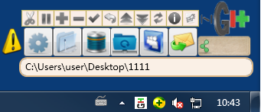

1. **Main Functions Area**



**1) Property Window:** Set the configuration of ngit. It’s necessary after installing/

**2) Working Area:** All operations about working area and index area

**3) Local Storage:** All operations in local repository

**4) Remote Storage:** All operations about remote server.

**5) Gerrit Functions:** N/A

**6) Git Message:** N/A

1. **Common Functions Area**



**1) Configure the Ignored files list.**

**2) Save current all works.**

**3)** **Add changes into index area.**

**4) Remove changes from index area**

**5)** **Commit the change from index area into local repository**

**6) Restore the current works.**

**7) Commit changes from local repository to remote server.**

**8) Get changes from remote server**

**9) Refresh:** Update local repository and working area from remote server

**10) Resolve Conflicts.**

**11) Show branch graph.**

1. **Other Functions**

**1)** ** Operation warning information.**

**2)  Current Working branch Information, it’s important.**

**3)  App Icon, it can move the app or hide the app.**

**.**

**4)  Tray Icon.**

**5) **

**Current working repository:**

**It can switch working repository (drag-drop/Click/context-menu).**

**Q/A**

1. **How to finish a full commit operation.**

**1.  Switch to developing branch.**

**2. Coding and save all files.**

**3. Add changes into index area.**

**4. Commit the change from index area into local repository**

**5. Commit changes from local repository to remote server.**

1. **How to Resolve Conflicts.**

**1.  Show warning information**

**2.  Show Conflict files list**

**3.Use context menu to resolve conflicts**

**4.Use context menu to commit all merge files**

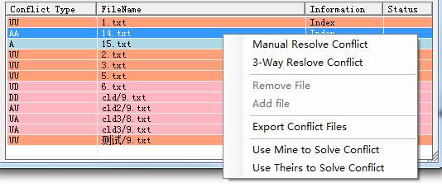

1. **How to implement the authority management**
2.  **Open the Property window**
3. 
4. 
5. **Upload the public key to server.**
6. **N/A**